Project Design Phase
Solution Architecture

Date | 28 September 2026
Team ID | SWTID-2026-6339
Project Name | AI BlogNest
Maximum Marks | 4 Marks

Solution Architecture:
Solution architecture is a complex process – with many sub-processes – that bridges the gap between business problems and technology solutions. Its goals are to:
- Find the best tech solution to solve existing business problems.
- Describe the structure, characteristics, behavior, and other aspects of the software to project stakeholders.
- Define features, development phases, and solution requirements.
- Provide specifications according to which the solution is defined, managed, and delivered.

Solution Architecture Diagram:

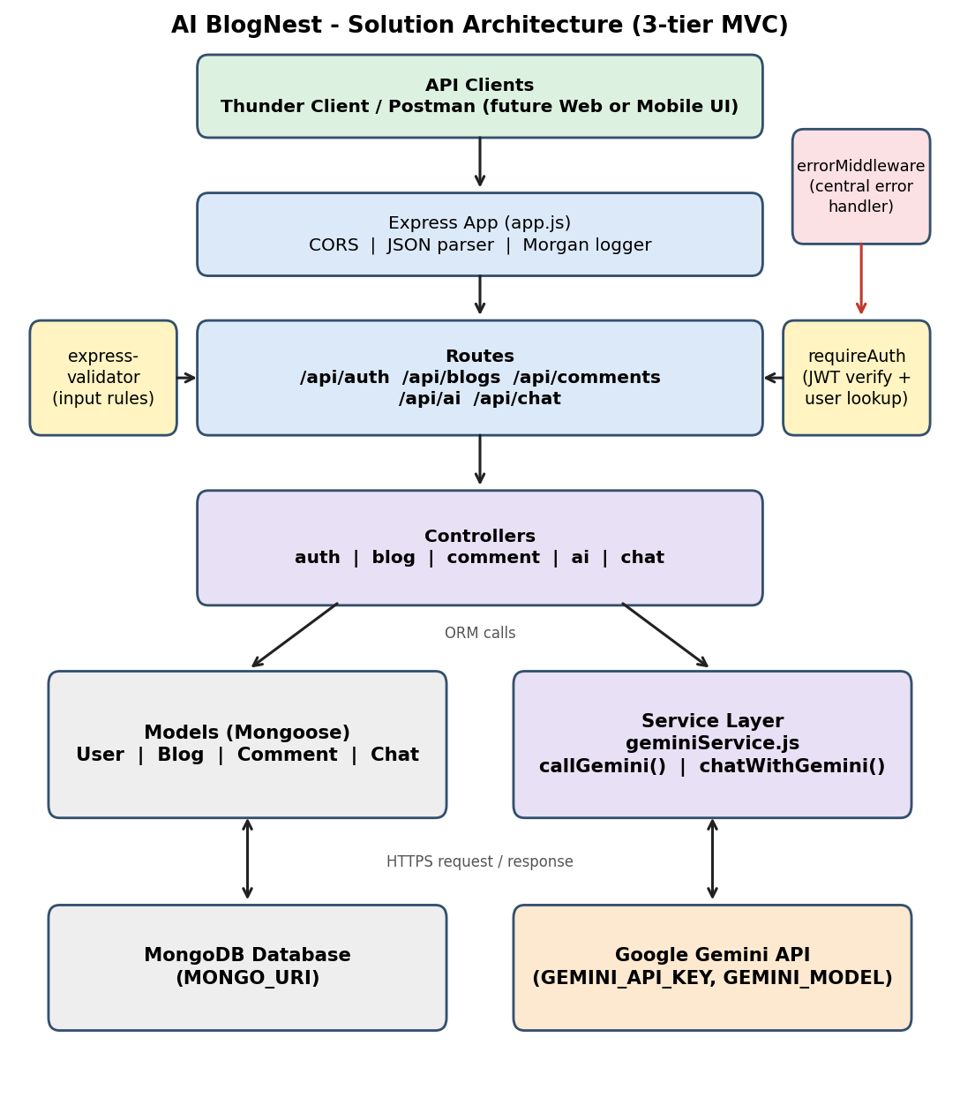
Figure 1: Architecture and data flow of the AI BlogNest API
The client sends HTTP requests to Express. Requests pass through CORS, the JSON parser and Morgan, then routes apply express-validator rules and the JWT middleware. Controllers call Mongoose models (MongoDB) or geminiService (Google Gemini) and return JSON. Errors are handled centrally by errorMiddleware.

